Logic Overview and Understanding –

**Logic Overview:**

1. **Initializing the Game**:
   * **Setup()**: Initialize the game variables such as the snake's initial position, fruit's position, score, and other necessary variables.
2. **Drawing the Game**:
   * **Draw()**: Render the game board by displaying the snake, fruit, and borders in the console or window.
3. **Taking User Input**:
   * **Input()**: Listen for user input (arrow keys or WASD) to change the direction of the snake.
4. **Snake Movement and Collision**:
   * **Logic()**: Update the snake's position based on the current direction. Check for collisions:
     + If the snake hits itself or the wall, end the game (**gameOver**).
     + If the snake eats the fruit:
       - Increase the score.
       - Generate a new fruit at a random position.
       - Increase the snake's length (**nTail**).

**Dry Run:**

Let's simulate a few steps of the game logic:

* **Setup:**
  + Initialize the game variables:
    - **gameOver = false**
    - **x, y = initial snake position**
    - **fruitX, fruitY = random fruit position**
    - **score = 0**
    - **nTail = 0**
* **Draw:**
  + Display the game board:

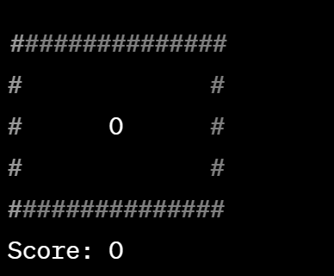

* **Input:**
  + User presses the right arrow key.
* **Logic:**
  + Update the snake's position based on the direction.
  + Check for collision:
    - No collision with the wall or itself.
  + Check if the snake eats the fruit:
    - Snake head position matches the fruit position.
    - Increase score by 10.
    - Generate a new fruit at a random position.
    - Increase snake length (**nTail**).
* **Draw (Updated):**
  + Display the updated game board:

This process continues as the user inputs directions and the snake moves accordingly. The game checks for collisions and updates the score and snake length as the snake eats fruits until a collision occurs or the game ends.

This dry run demonstrates the basic flow of the game's logic for a single step. In reality, this process continues in a loop until the game ends or the player quits.